There is a Streamlit app that I’ve just built and hosted. Hardly any users. I’m not using a docker container, just as a systemd service in a pip virtual environment
However I noticed that after a user runs training, the cpu usage drops but the memory usage doesn’t, even though I’m clear the Streamlit cache in my app.py file. Please see Prometheus chart below
The only thing that seems to get the memory usage down is restarting the service on the server and so I could set up a cron job to do this.

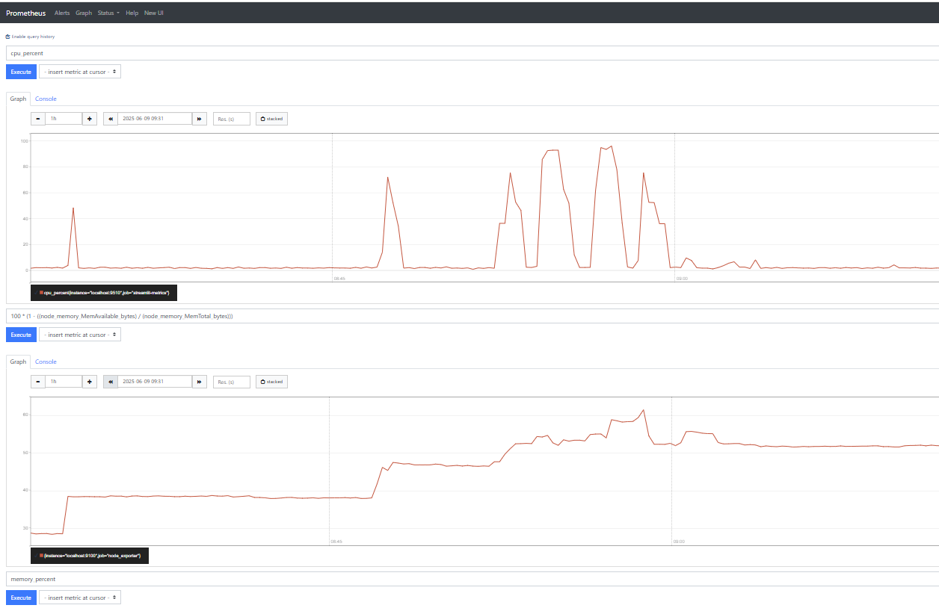
Do you have any thoughts on this.
App is here: https://mlrwp-diag.uk-ba.net
Metrics:
http://mlrwp-diag.uk-ba.net:9090/classic/graph?g0.range_input=30m&g0.expr=100%20*%20(1%20-%20((node_memory_MemAvailable_bytes)%20%2F%20(node_memory_MemTotal_bytes)))&g0.tab=0&g1.range_input=30m&g1.expr=100%20*%20(1%20-%20((node_memory_MemAvailable_bytes)%20%2F%20(node_memory_MemTotal_bytes)))&g1.tab=0&g2.range_input=1d&g2.expr=memory_percent&g2.tab=0&g3.range_input=1d&g3.end_input=2025-06-07%2017%3A09&g3.expr=nginx_connections_active&g3.tab=0

I used this code in my streamlit file to free up memory after training had run:
# This clears the cache for the next user but preserves the current view
if st.session_state.results:
if st.sidebar.button("Release Memory (Training Complete)"):
# Clear Streamlit cache
st.cache_data.clear()

# Clear session state variables that might hold large objects
for key in list(st.session_state.keys()):
if key.startswith('model_') or key == 'results' or key == 'current_run_figures':
del st.session_state[key]

# Aggressive garbage collection
import gc

# Run garbage collection multiple times
for _ in range(3):
gc.collect()

# Force memory release to OS (Linux-specific)
try:
# Get the current process
process = psutil.Process(os.getpid())

# For Ubuntu 24.04, use malloc_trim from libc
import ctypes
libc = ctypes.CDLL('libc.so.6')
libc.malloc_trim(0)

# Additional Linux-specific memory pressure technique
with open('/proc/sys/vm/drop_caches', 'w') as f:
f.write('1')
except Exception as e:
st.sidebar.warning(f"Note: Some advanced memory release failed: {str(e)}")

